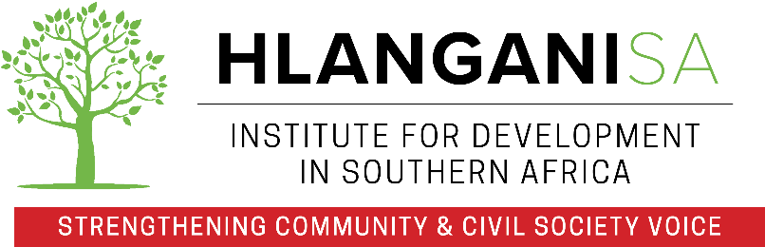

CALL FOR SERVICE PROVIDERS: Training and mentorship of community-based organisations in Malawi, South Africa, Zambia and Zimbabwe on gender-based violence and disability.

HLANGANISA Institute of Development in Southern Africa (Hlanganisa) is a renowned grant maker that channels funding and provides accompaniment to community-based organisations (CBOs) aimed at protecting human rights, promoting social justice, fostering active citizenry and delivering key services to marginalized sub-populations. A key component of Hlanganisa’s work is to support the integration of GBV and disability programming at grassroots level. This is done through building institutional resilience and supporting disability inclusion in programming.
The COVID pandemic has severely impacted the work of many CBOs, not least those servicing the needs of women affected by GBV. Because many of these CBOs support vulnerable sub populations like women with disability, this constituency has been grossly impacted. Hlanganisa is undertaking a multi-country intervention aimed at building resilience of such CBOs and ensuring that they continue to provide these critical services.
Hlanganisa is therefore looking for implementing partners (IPs) in the 4 countries. The IPs should be organizations working with disabled persons (umbrella bodies welcome to apply) with training experience and the requisite capacity to conduct monitoring and support visits. They should have a physical presence in the selected country and have a pool of experienced facilitators. Experience in advocacy and developing module-based toolkits and learning materials for national and grassroots non-profit organisations will be assessed favourably.
Scope of assignment
Successful implementing partners will be required to
- Conduct a total of eight (8) days of training per year using the above-mentioned toolkit in their support.
- Conduct two (2) support visits per CBO per year.
- Remotely provide ongoing technical support to three CBOs.
- Develop advocacy material specific to one country.
- Support Hlanganisa in updating existing toolkit.
- Translation to braille (although this is not a mandatory requirement for service providers).

Interested organisations are invited to submit an expression of interest to info@hlanganisa.org.za subject line should be labelled GBV & Disability Training Services – [Name of Country]. EOI should reach Hlanganisa no later than 29th November 2021, 11.59pm South African time.
The EOI should comprise of the following:
- Document highlighting the organisation’s suitability for the assignment and relevant experience.
- A detailed budget for conducting activities outlined above (in USD) inclusive of all travel and logistics.
- Clear demonstration of training experience or any example of similar work done previously.
The expected start is December 2021 and the total number of days assigned for this assignment is fifteen (15). Please send any enquiries to info@hlanganisa.org.za by 24th November 2021.

